**University of Petroleum and Energy Studies**

School of Computer Science

Department of Cybernetics



**Graphics & Animation Tools**

**Project Report**

**(Session: 2020-2021)**

Course: B. Tech with Specialization in Open Source and Open Standards

Batch: 2017-2021

Semester: VIIth

**Submitted By:**

Nikhil Mishra

R100217043

500062584

**Submitted To:**

Dr. Durgansh Sharma Assistant Professor

Department of Cybernetics

**Aim:** Design of 3D Swinging Ball Illusion using Blender.

**Steps followed:**

1. Open Blender.
2. Clear the default interface of the blender by deleting or hiding the cube.
3. To create a plane, press Shift+A and select a UV sphere.
4. For the cable of the cylinder select a cylinder after pressing Shift+A again.
5. Pull the cylinder up the z axis and scale it down to make it thin so that it looks like a cable.
6. Go into edit mode by pressing tab and grab the vertices of the cylinder to move it down such that origin point is at the top of the cylinder.
7. Go to face select mode, garb the bottom face of the cylinder and pull that face down to create a long cable.
8. Now, to join the ball and cable together first select the ball, then shift select the cylinder or cable and then press Ctrl+J to join both the meshes into one.
9. Press Shift+A to add a circle, then hit R and then 90 degrees to rotate it along the X axis.
10. Scale the circle such that it’s larger than the sphere.
11. Now, press Ctrl+R and tap G to add two vertices at the top of our circle right before the cable that’s coming down so we can delete that centre vertex in the middle, and we click on the reveal hidden vertices.
12. Press X and delete the vertex in the middle.
13. Now as all the vertices are selected, zoom out, grabbing all and press E to extrude them out to make larger.
14. Go to modifiers and select solidify modifier.
15. Change the offset to 0 to make the axis in the middle and then adjust the thickness of the ring.
16. Now, add Subdivision surface modifier to get a rounded bent cylinder.
17. Right click to shade smooth and then go into edit mode by pressing tab and then press Ctrl+R to make the corners of the ring broader.
18. Now, to animate the ball so that it swings back and forth, first split the window to get a graph editor.
19. Get the hanging sphere and in right orthographic view, grab the sphere and rotate it by 30 degrees.
20. For key frame check the automatic key frame insertion and grab the sphere and let it go, this will automatically add a keyframe on frame 1.
21. Now, click on frame 120, as it will be sufficient time for a 60fps animation and rotate the ball 60 degrees negative.
22. Now click on 0 till 240 frames as to get a looping animation and copy the first key frame to frame 240.
23. Go to render settings and chose 60 fps as the frame rate.
24. Press N to get the properties tab in the graph editor.
25. Select the drop down on the object and uncheck the visibility and all of the different accesses except for the X rotation access, then go to the modifiers tab and add a new modifier choose cycle from the modifier list and add on that axis to make the simulation loop perfect.
26. Now, to get the second swinging ball, select the first ball, press Shift+D, go to the graph editor and turn off the X rotation and turn on the Z rotation.
27. Press G and grab all the key frames on the Z rotation and pick them along the Y 90 to make it move up in the timeline and give it a 90-degree rotation along the Z axis.
28. To avoid the balls hit each other, grab the second ball that was just duplicated and turn all on the axes in the graph editor.
29. Pick the three key frames from the timeline and move the 60 frames to the left.
30. This avoids collision between the balls.
31. To add a plane, press Shift+A and select plane and adjust it in such a way that it is underneath the cylinder and serves as a floor.
32. Select the cylinder, rotate it by 90 degrees on frame 1 so that it automatically adds a key frame which is aligned with our first swinging ball.
33. Now select the cylinder and jump to frame 60, go to top view and rotate it by 90 degrees along the Z axis.
34. Select all of the key frames in the graph editor on that cylinder and press V and choose vector as the key frame handle type, so that it spins without any curves between it as it is going to spin at a consistent speed the whole time.
35. Now, for rendering, go to ‘output properties’, select ‘Output’ and click on ‘folder icon’ to set your output video location (e.g. Desktop) and then click on file format, change it to ‘FFmpeg video’.
36. Finally, go to ‘Render’ and click on ‘Render Animation’, your video (.mkv) file will be exported on Desktop.

**OUTPUT:**

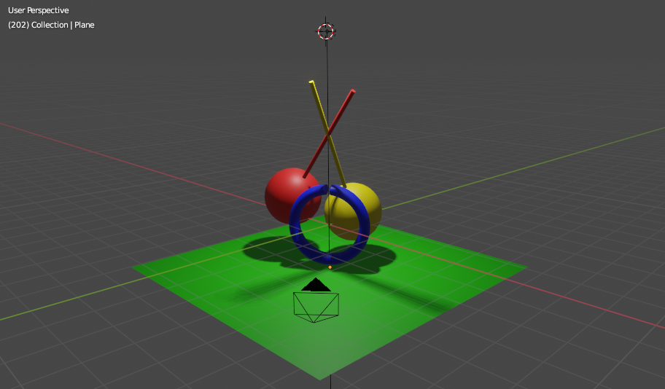

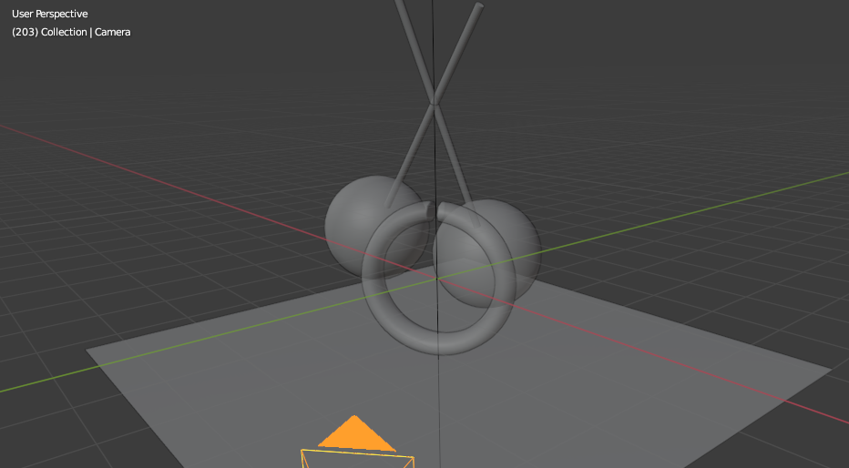

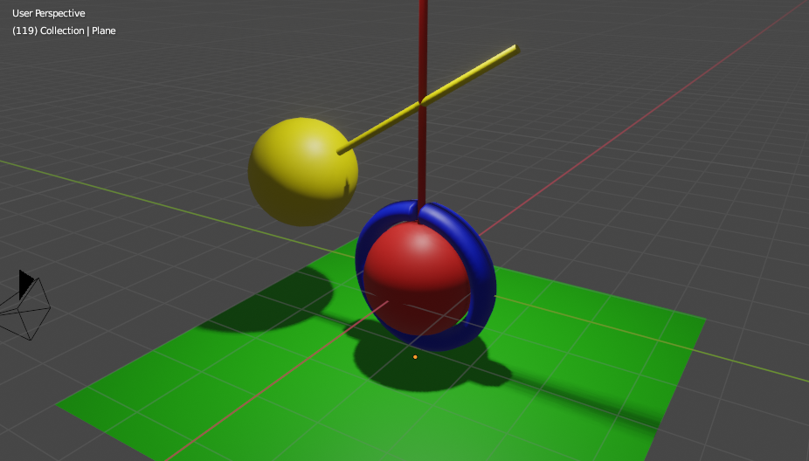

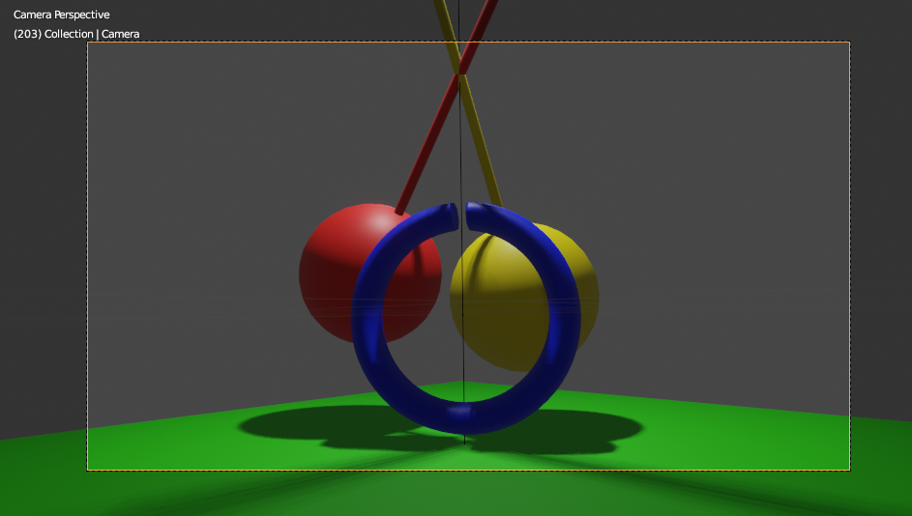

**Google Drive Link:** [**https://drive.google.com/drive/folders/18C0VtIAk-awUy3Axst3degZLR7YdXza2?usp=sharing**](https://drive.google.com/drive/folders/18C0VtIAk-awUy3Axst3degZLR7YdXza2?usp=sharing)